**Clearly stated research question you are trying to answer through your project**

The main research question that we intend to address in this project is to what extent can real time monitoring of a known patient can be monitored accurately accounting for the everyday physical movements that he/she may be subject to. For that we intend to develop a machine learning algorithm and test whether it will be able to successfully analysis and discard the unwanted signals produced through motion artifacts. Finally, for such a vast population of Pakistan with a low median wage, to manufacture our own novel wrist device along with its smart monitoring system which can obtain at least the same level of accuracy as the E4 smart band hence reducing its cost significantly.

**Research Design (methods, process, methodology etc.)**

The overall model of this system can be simplified using the following diagram:

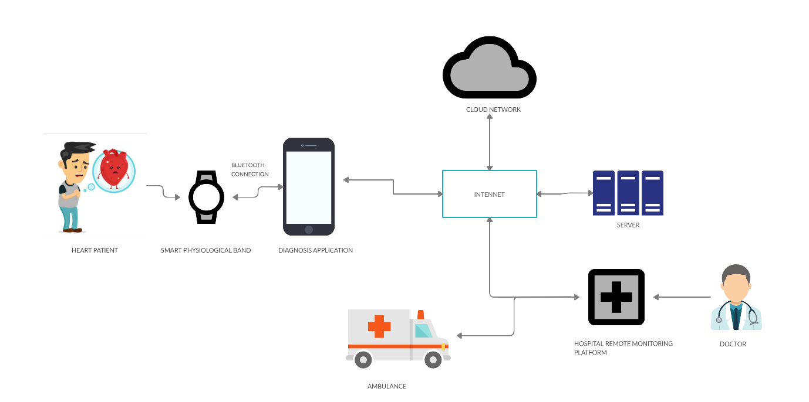

For our project we intend to:

* Create a smart and relatively cheaper physiological band that continuously monitors the hearth rhythms of the patient with the help of PPG signals.
* Ensure continuous transfer and storage of data both locally and on server using a Diagnosis App developed for smartphone which will have receive data from the device through a Bluetooth connection.
* Real time Alert for the prescribed Doctors as well as Emergency Alert to the patient in case a warning symptom is detected. The alerts will enable both the medical staff as well as the patient to carry out preventive measures.
* Collect more data from known patients for increased accuracy and reliability of our research.
* For real time monitoring, work on motion artifacts and figure out a way to remove these artifacts in the processing stage of the signal.

Considering the complexities and the high work load involved in this project, it will be extended to our SProj 1 and 2. For the summers, due to unforeseen circumstances led by Covid 19, we will rely on already available data and work on to devise up with a computer design and simulation for our hardware i.e. Smart physiological band. For that to be successful, we will have to go through the previously completed progress of this project which includes understanding the system level design as well as the instruments and tools which includes software packages and their code for signal processing in python language as well as the working principle behind the Emamptica E4 smart band.